**Unix administration project**

**Installation of apache2 web server and virtual host configuration same Ip and different name and different port number**

**Unix system administration**

Final project

|  |  |
| --- | --- |
| Submitted to | Osman salem |
| Submitted by | Roshini Vijayakumar |
| Email | roshini.vijayakymar@epita.fr |
| Date | 24/07/2022 |

1.Installing apache2 in ubuntu

2. CONFIGURE APACHE TO LISTEN TO PORT 80,8080

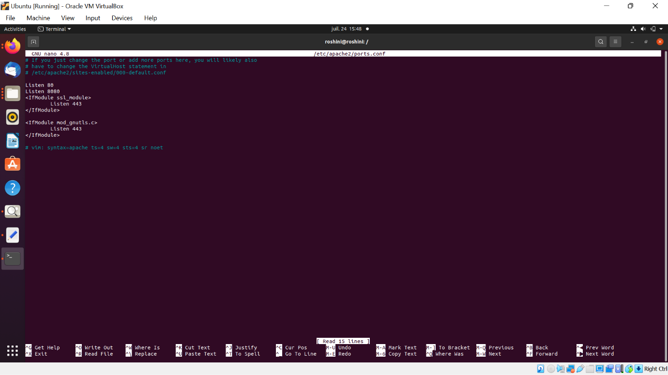

CREATE A VIRTUAL HOST CONFIGURATION FILE

TEST BOTH THE WEBSITES

